#include<stdio.h>

#include<stdlib.h>

void insertionSort(int arr[], int size){

int x, j;

for(int i=1; i<size; i++){

x = arr[i];

j = i-1;

while(arr[j] > x && j > -1){

arr[j+1] = arr[j];

j--;

}

arr[j+1]=x;

}

}

int\* getArray(int n){

printf("Enter the elements in array: ");

int\* arr = (int\*)malloc(sizeof(int)\*n);

for(int i=0; i<n; i++)

scanf("%d",&arr[i]);

printf("Success :)\n");

return arr;

}

int main(){

printf("Enter no of elements you want in the array: ");

int n;

scanf("%d",&n);

int\* array = getArray(n);

insertionSort(array, n);

printf("Sorted Array: \t");

for(int i=0; i<n; i++)

printf("%d ",array[i]);

printf("\n");

return 0;

}

int main(){

printf("Enter no of elements you want in the array: ");

int n;

scanf("%d",&n);

int\* array = getArray(n);

insertionSort(array, n);

printf("Sorted Array: \t");

for(int i=0; i<n; i++)

printf("%d ",array[i]);

printf("\n");

return 0;

}

Insertion Sort :

Output :

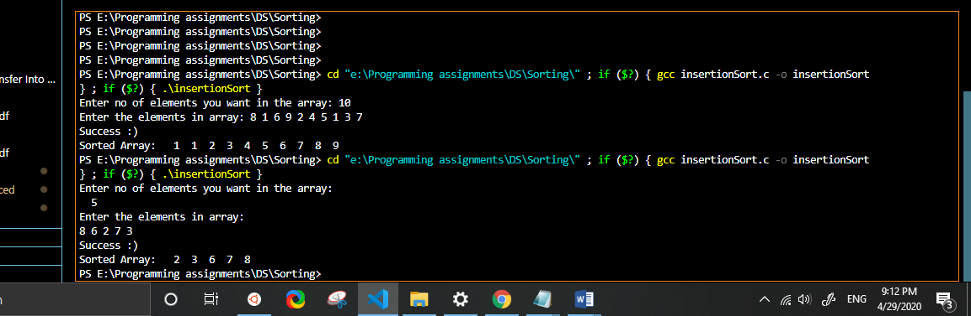

int\* getArray(int n){

printf("Enter the elements in array: ");

int\* arr = (int\*)malloc(sizeof(int)\*n);

for(int i=0; i<n; i++)

scanf("%d",&arr[i]);

printf("Success :)\n");

return arr;

}

int main(){

printf("Enter no of elements you want in the array: ");

int n;

scanf("%d",&n);

int\* array = getArray(n);

selectionSort(array, n);

printf("Sorted Array: \t");

for(int i=0; i<n; i++)

printf("%d ",array[i]);

printf("\n");

return 0;

}

#include<stdio.h>

#include<stdlib.h>

void swap(int \*n1, int \*n2){

int temp = \*n1;

\*n1 = \*n2;

\*n2 = temp;

}

void selectionSort(int arr[], int size){

int minIndex, i,j;

for(i=0; i<size; i++){

minIndex = i;

for(j=i+1; j<size; j++){

if(arr[j]<arr[minIndex])

minIndex = j;

}

swap(&arr[i],&arr[minIndex]);

}

}

Selection Sort :

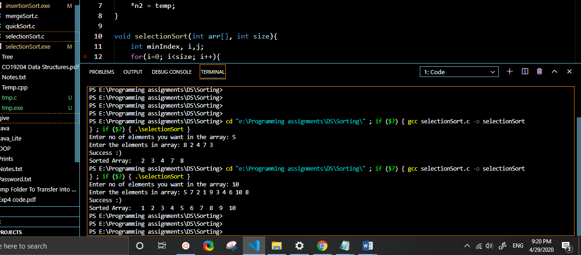

Output :

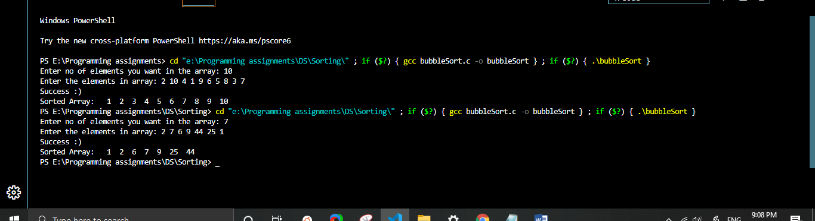

#include<stdio.h>

#include<stdlib.h>

void swap(int \*n1, int \*n2){

int temp = \*n1;

\*n1 = \*n2;

\*n2 = temp;

}

void bubbleSort(int arr[], int size){

int flag;

for(int i=0; i<size-1; i++){

flag = 0;

for(int j=0; j<size-1-i; j++){

if(arr[j]>arr[j+1]){

swap(&arr[j], &arr[j+1]);

flag = 1;

}

}

if(flag==0)

return;

}

}

int\* getArray(int n){

printf("Enter the elements in array: ");

int\* arr = (int\*)malloc(sizeof(int)\*n);

for(int i=0; i<n; i++)

scanf("%d",&arr[i]);

printf("Success :)\n");

return arr;

}

int main(){

printf("Enter no of elements you want in the array: ");

int n;

scanf("%d",&n);

int\* array = getArray(n);

bubbleSort(array, n);

printf("Sorted Array: \t");

for(int i=0; i<n; i++)

printf("%d ",array[i]);

printf("\n");

return 0;

}

Output :

Bubble Sort :